STUDENT IDENTITY CARD
(To be filled in BLOCK LETTERS)

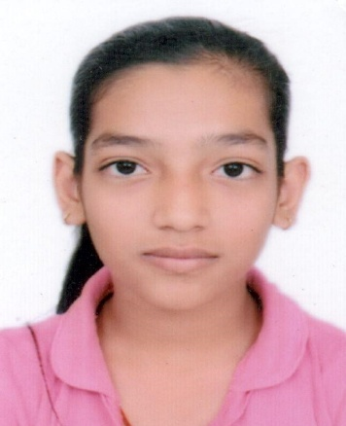
ROLL NO. : …..24/CSE/194..… DEPTT. ….………………CSE..…………......…..
NAME : ……………………………RIYA GUPTA………………………………………..…..
CLASS : ………..B.TECH CSE – C ..………… D.O.B.: ………11-06-2006…………
ADD. : ………….H.NO. – 129, OLD HOUSING BOARD COLONY……………….
……………ROHTAK, HARYANA (124001)…………………………………….
MOB. NO. : …………………………8930228386…………………………………………..
VALID UPTO : ……………………..2024 - 2028……………………………………………
ABC ID........…………………..…848513385763…………………………………………..

